**Nov 2016 HL P1**

**Section A**

1. State **three** potential usability issues with cell phones. [3]
2. (a) State the purpose of cache memory. [1]  
     
     
     
     
   (b) Draw a diagram to show the relationship between random access memory (RAM),

the processor and cache memory. [1]

1. Outline **one** advantage and **one** disadvantage of wireless networks. [4]
2. Construct a truth table for the Boolean expression not (A xor B) and C.

Use the following headings in your table.

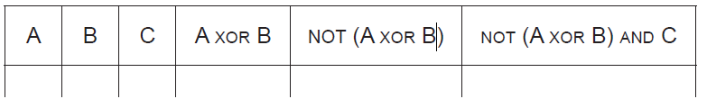 [4]

1. Many different people and organizations upload scientific materials to the internet.

A student uses data from the internet in a science project.

Outline **two** ethical issues concerning this use of the internet. [4]

1. Consider the following recursive algorithm FUN(X, N), where X and N are two integers.

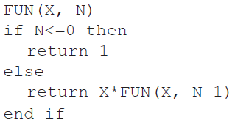

The return statement gives the value that the algorithm generates.

1. Determine how many times multiplication is performed when this algorithm is executed. [1]
2. Determine the value of FUN(2,3), showing all of your working. [3]
3. State the purpose of this recursive algorithm. [1]
4. 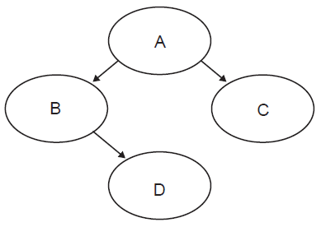Consider the following binary tree.
5. Identify all leaf nodes in this binary tree. [1]
6. For this binary tree, state the result of:
7. inorder tree traversal, [1]
8. postorder tree traversal. [1]

**Section B**

1. A book shop has a computer at each point of sale, and also a central computer.

When a customer buys a book in the book shop, the salesperson at the point of sale uses a

scanning device to input a barcode from the book.

The barcode is sent to the central computer where the barcode of each book and the

corresponding price are held in a database on a disk.

When the price is found, it is sent to the point of sale computer where all necessary

calculations are performed, details of the transaction are stored on a local disk and a receipt

is printed out.

1. Construct a system flow chart for the system described above. [5]

At the point of sale there are peripheral devices other than the scanning device and printer.

1. Outline the purpose of one other possible peripheral device in this scenario. [2]

The customers can also buy books online. A customer can select a book, and then enter  
 their name, address and credit card number. This data is stored on the book shop’s  
 central computer in a database of customer orders.

1. Outline the purpose of protocols in transferring this data. [2]
2. (i) Identify two sources of risk to personal data in this online system. [2]

(ii) State two measures that the book shop can take to address the risks identified

in part (d)(i). [2]  
  
  
(iii) Outline the consequences to the customer if their data is not adequately protected. [2]

1. A new higher level programming language is being developed.
2. Identify **two** reasons why consistent grammar and syntax should be essential features

of a higher level programming language. [2]

1. Identify **two** features of a user interface that will allow application programmers to

interact more easily with the programming language. [2]

1. State one method of providing user documentation. [1]

Application programmers who use this programming language will be able to choose to use  
 either an interpreter or a compiler.

1. (i) Outline the need for an interpreter or a compiler. [2]  
     
     
     
   (ii) Describe one advantage to application programmers of having both an

interpreter and a compiler available. [2]

One of the predefined sub-programs in the new language is sumOdd(). It accepts an integer  
 N as input. If N<=0 it outputs -1, otherwise it outputs the sum of the first N odd numbers.

For example:

sumOdd(4) outputs 16, because 4 is not less than 0, and 1 + 3 + 5 + 7 = 16.

sumOdd(−3) outputs −1, because −3 is less than 0.

1. Construct, in pseudocode, the algorithm for sumOdd(). [4]
2. Outline the need for predefined sub-programs and collections. [2]
3. The temperature, humidity, light levels and automatic watering of plants inside the

greenhouses (glasshouses) of a garden centre are centrally monitored and controlled.

1. Define the term analog data. [1]
2. With reference to sensors, transducers and the processor, explain the control process

that takes place in the greenhouse (glasshouses). [5]

1. Outline the role of the operating system specific to this scenario. [4]
2. Describe the difference between polling and interrupt in the event that some of the

sensors malfunction. [3]

1. Compare a centrally controlled system with a distributed system. [2]
2. The diagram shows a list of names held in a circular linked list. The end of the list is pointed

to by an external pointer, X.

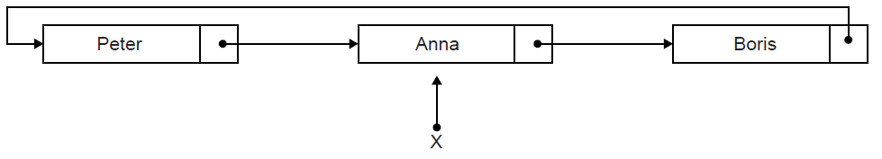

1. State the first name in this circular list. [1]

Two operations are performed on the list in the following order:  
 1. A node containing the name Sarah is inserted at the beginning of the list.  
 2. A node containing the name Ken is inserted at the end of the list.

1. Sketch a diagram showing the resulting circular linked list. [3]
2. Describe how the number of names held in this list could be determined. [4]
3. Explain how a stack could be used to output, in reverse order, all names held

in the linked list. [4]

1. Compare the use of static and dynamic data structures. [3]
2. A two-dimensional array, A, has N rows and N columns, where N is a positive integer.

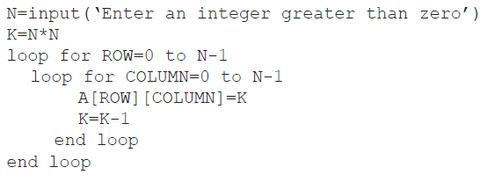The following algorithm is written to fill array A with the numbers 1, 2, 3,…, N2.

1. Trace the algorithm, with an input of N=3, to show the contents of array A after the

algorithm has been executed. [3]

There are many different ways of placing the numbers 1 to N2 into an N × N two-dimensional array.  
 The following two-dimensional array, with dimensions 5 × 5 has been filled in a circular  
 (spiral) pattern with numbers 1 to 52.

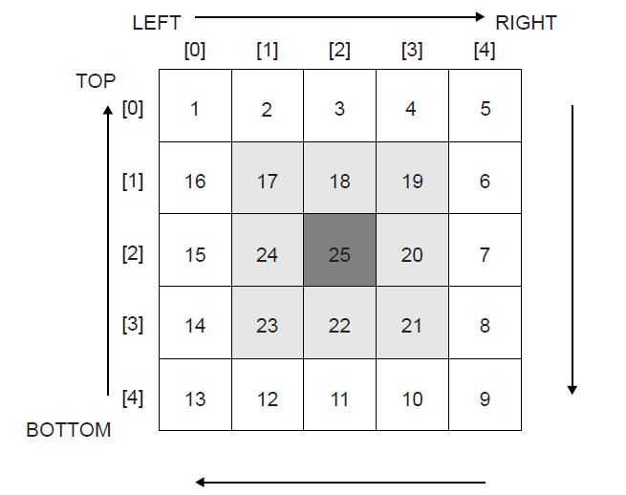

The general process of filling an N × N two-dimensional array, in a circular (spiral) pattern,  
with numbers from 1 to N2 could be described as follows:

• initialize Z=1,

• initialize TOP, BOTTOM, LEFT and RIGHT,

• iterate until the whole array is filled,

• each time Z is placed correctly increase the value of Z by 1,

• fill the elements of the TOP row starting from LEFT to RIGHT,

• increase TOP by 1 before filling the elements of the RIGHT column,

• fill the elements of the RIGHT column starting from TOP to BOTTOM,

• decrease RIGHT by 1 before filling the elements of the BOTTOM row,

• and continue filling the BOTTOM row and LEFT column in a similar way,  
 adjusting TOP, RIGHT, BOTTOM and LEFT accordingly.

1. (i) State the initial values for TOP, BOTTOM, LEFT and RIGHT. [1]

(ii) State the consequence of not increasing TOP by 1 before starting to fill the  
 elements of the RIGHT column. [1]

(iii) In the algorithm described above, state the indices (subscripts) of the first and  
 the last element to be filled in the BOTTOM row. [1]

1. Construct, in pseudocode, an algorithm to fill an N × N two-dimensional array, in a

circular (spiral) pattern, with numbers from 1 to N2 as described above. [9]